## Preliminary Investigation of Non Destructive Evaluation Techniques for Parts Produced by Additive Manufacturing

Jeffrey McIsaac and Mohammadarmaan Bandi, Mohawk College Additive Manufacturing Innovation Centre

Doug Whitely, Canadian Institute for NDE

## Introduction

Additive manufacturing, or 3D printing, is a technology which is disrupting conventional manufacturing processes[2,3]. The use of AM allows for parts to be produced directly from a solid model, and greatly simplifies the production of prototypes and individual parts[2]. More importantly, it allows control over the internal features of a part, thereby enabling the use of new part geometries that are impossible to produce using conventional techniques[3,4]. As a result of these changes, the part properties and the part microstructure differ greatly from those that are produced from conventional techniques [1,2,4]. Part evaluation, and in particular non-destructive evaluation (NDE) techniques, must be adapted to analyse key features of these parts. NDE is particularly important for AM parts as internal features are often incorporated into AM parts, and these can only be inspected via NDE. Analysis of the effectiveness of standard NDE techniques on AM parts is therefore required to facilitate adoption of AM parts in industry[5,7].

## Overview of Additive Manufacturing

All additive manufacturing techniques are based on the principle that a three dimensional structure can be created out of a set of two dimensional layers. Parts are designed as solid models in CAD, and then are sliced into two dimensional layers [1,2]. The thickness of each layer is a key process parameter and will vary depending on the type of process used, and the material selected. In metal additive manufacturing, for example, this layer thickness can vary from 20 to 60 microns, depending on the alloy selected[2,7]. In plastic 3D printing this thickness can range as high as 100 to 150 microns[8].

The sliced layers are fed to the 3D printing system which then creates a path plan in X and Y dimensions for each layer. The material is deposited in the pattern defined by that layer, or slice of the part. The print head then moves in the Z direction to allow the next layer to be produced. The process ensures that each subsequent layer is securely bonded to the layers below to avoid delamination of the part. In this way the part is built up one layer at a time.

## Powder Bed Fusion (PBF) Additive Manufacturing

Powder Bed Fusion (PBF) is the most widely adopted technique for metal additive manufacturing[1,2]. In this technology the material is delivered as a bed of powder. The powder is laid down in the desired work space by a recoat blade (figure1). The thickness of this layer of powder defines the layer height of each layer in the print design. A laser beam is then used to melt the powders in the two dimensional pattern for that layer of the part. The heat of the laser generates a weld pool to bond the powders in that layer, and to ensure that the layer is welded to the layers below. Height in the Z dimension is achieved by the powder bed dropping away from the workspace of the recoat blade and the focal point of the laser beam[2,3].

 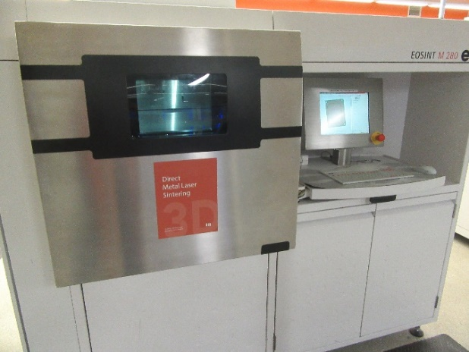

(a) (b)

Figure 1- The Powder Bed fusion process; (a) image adapted from [3]; (b) EOS M280 Direct Metal Laser Sintering system at Mohawk College’s Additive Manufacturing Innovation Centre

By producing the parts one layer at a time, the internal features of the part are accessible. The design can therefore incorporate internal features, such as cooling channels, which cannot be formed using any conventional techniques (figure 2). This control over internal features has emerged as one of the most significant technological advantages of AM over conventional techniques, and it is drawing interest from various industries including injection molding, die casting, and aerospace [2,3,5].

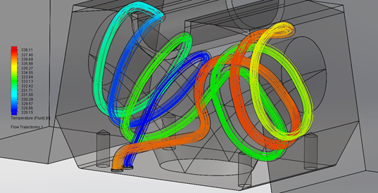

Figure 2: Mold block designed with internal, conformal cooling channels

## Non-Destructive Evaluation

Given the complexity of the internal features that can be created using this technique, inspection of these parts by conventional NDT techniques has to be validated and the possibility that adopted, improved or new techniques may be required for use with AM parts, to ensure the successful adoption of this technique in these industries. As shown in Figure 3, the microstructures created by PBF are unique, however, and therefore there is a need to validate that reliable and repeatable results can be generated when NDE techniques are applied to AM parts[5,7].

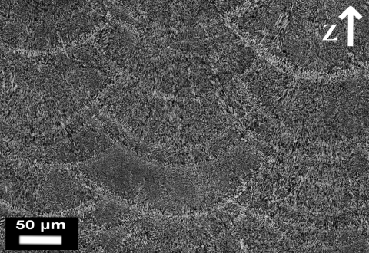

Figure 3: Optical micrographs of AlSi10Mg samples produced by means of DMLS[2]

## Development of Test Coupons

In order to confirm the viability of NDE techniques with AM parts, Mohawk Colleges’ Additive Manufacturing Innovation Centre (AMIC) partnered with the Canadian Institute for Non Destructive Evaluation (CINDE). Test coupons were prepared using various standard geometries, and then evaluated using NDE techniques. The coupons were produced on an EOS M280 machine (shown in Figure 2, above).

The first set of coupons are shown in Figure 4, below. These coupons were produced using MS1, a maraging tool steel produced for use in the AM industry. The coupons were 0.5 in. wide with height increasing in 0.5 in. increments, ranging from 0.5in. to 3.0in. The blocks were each 4in. in length.

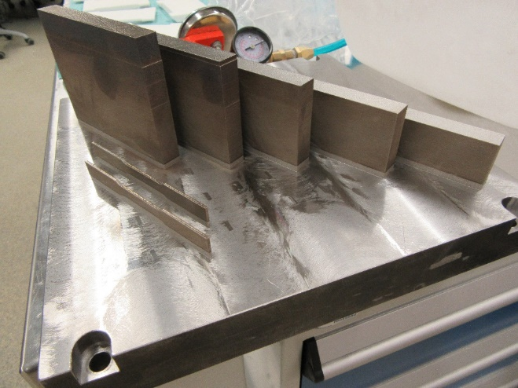

Figure 4: Coupons produced using MS1

Next, we experimented with Ti64 titanium. A second set of test blocks were produced, with the same geometries as the blocks of MS1. Some challenges were experienced in the printing process, whereby high residual stresses in the blocks resulted in the parts deforming during the printing process (see Figure 5). These parts were subsequently machined to remove the damaged portions, resulting in different test heights than the MS1 blocks.

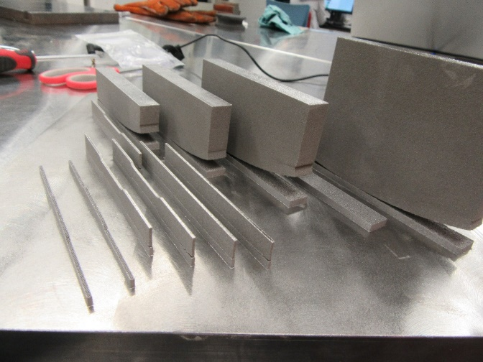

Figure 5: Coupons produced using Titanium alloy showing delamination at the substrate interface due to residual stress

Good sensitivity was achieved on both materials, with 1% to 2% section thickness evident (see Charts 1 and 2 below). Some experimental error may been encountered on Exposure 7, however the reasons for this are unclear. No discontinuities were detected in any of the blocks through this testing.

**Chart 1 - EOS Maraging Steel MS1**

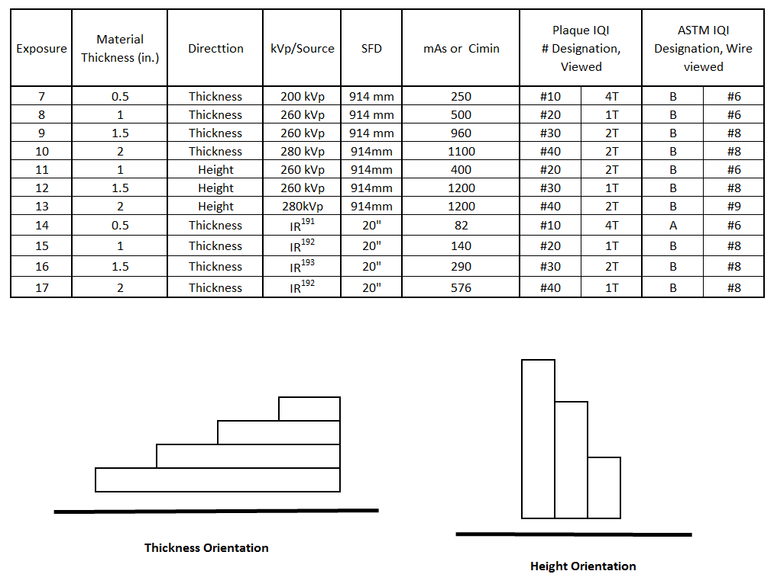

**Chart 2 - Titanium Alloy**

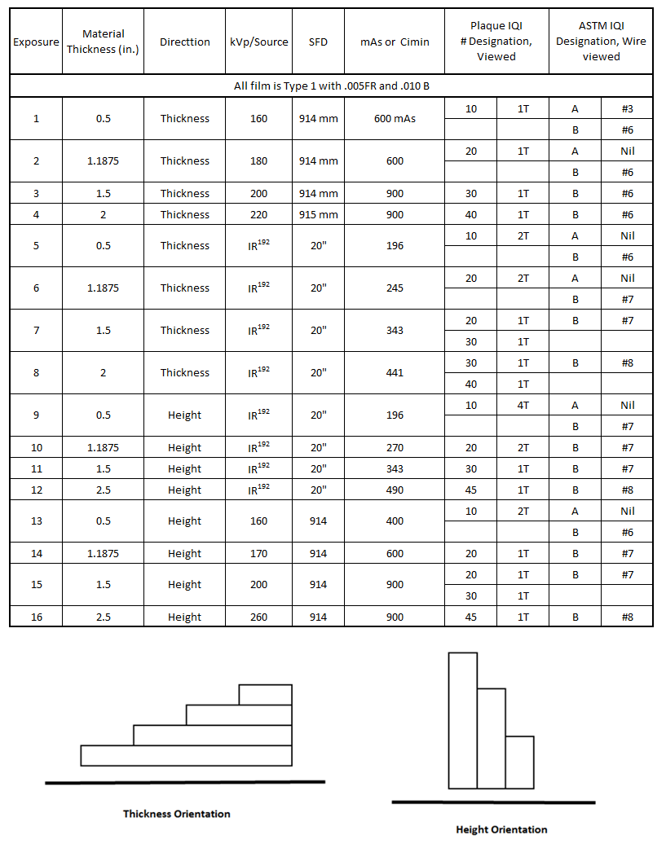

Other Forms of Inspection

Ultrasonic Inspection was performed on the blocks. A contact type inspection was performed, using a 5.0 MHz probe calibrated to the IIW Block (1018 Carbon Steel), 1.5 mm dia. SDH. The carbon steel IIW Block was used as CINDE does not have a titanium IIW Block and the attenuation value in steel is nearly double that in Titanium.

Through this testing no discontinuities or anomalies were detected. Signal to noise ratio was excellent at 20:1 ratio.

Liquid Penetrant inspection was also performed. Water Washable penetrant and Dry Powder developer were used for the Maraging steel blocks, and Fluorescent Water Washable penetrant and Dry Powder developer were used for the Titanium blocks. Neither inspection showed any surface breaking discontinuities.

With the success of the first two trials we undertook the development of a different style of test block. It was decided to implant internal discontinuities of known size and position. Four types of discontinuities were to be implanted into the block.

Chart 3: Dimensions of features in AlSi10Mg step block

|  |  |  |  |  |  |
| --- | --- | --- | --- | --- | --- |
| Defect Series | Hole Type | Location | Unfused Powders | Diameter (% of section thickness) | Length (mm) |
| A | Side Drilled Holes (SDH) | Exposed to surface | No | 1%, 2% and 4% | 12.7 |
| B | Side Drilled Holes (SDH) | Internal and closed | Yes | 1%, 2% and 4% | 12.7 |
| C | Hidden Spheres | Internal and closed | Yes | 1%, 2% and 4% | -- |
| D | Bottom Drilled Holes (FBH) | Exposed to surface | No | 1%, 2% and 4 | 12.7 |

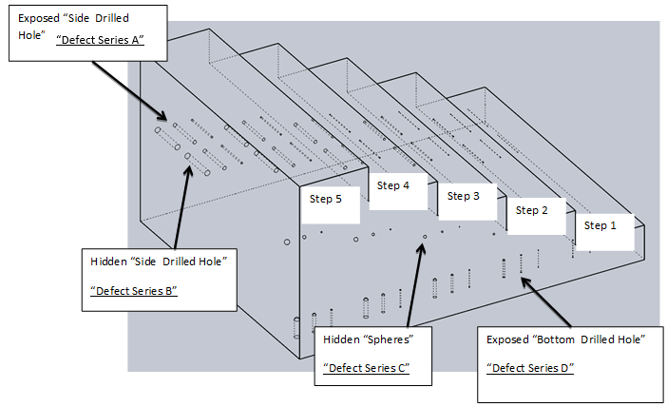

Figure 6: Step calibration block produced using AlSi10Mg

The sample block was radiographed (x-ray only), ultrasonically scanned and surface inspected.

Radiography was performed using Type 1 film and both wire and plaque IQI’s were used (see Figure 7 below).

Due to surface roughness, ultrasonic inspection was performed in an immersion tank. An Olympus 600 Flaw detector combined with a 5.0 MHz, .5in. dia. transducer (non-focused) was used. Sensitivity calibration was performed using a 5/64in. (1.98 mm) dia. FBH (Flat Bottom Hole) in 3.750in. (95.25 mm) block of 7075 Aluminum.

For liquid penetrant testing, the penetrant was Ardrox 970-P10 – Fluorescent Water-washable, in conjunction with Ardrox 9D1B – Dry Powder developer.

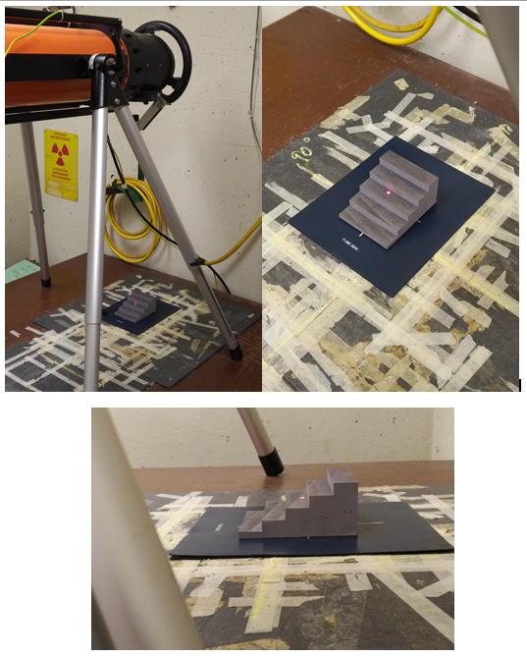

Figure 7: Step block test setup for radiography

Results:

The radiographic sensitivity achieved was again excellent with sensitivities less than 1% of section thickness being obtained in many of the radiographs regardless of the thickness inspected. Two of the four sets of features are fully contained within the specimen and would have retained unfused powders. For defect Series “B” and “C”, the areas which contained unfused powders were evident on the radiographs. See Chart 4 for details.

Ultrasonically the results were very good with the known defects presenting quite readily. The Series D defects were shown to not be flat bottomed, but are hemispherical in shape at the hole tip. See Chart 5 for details.

Penetrant inspection revealed no discontinuities.

**Chart 4 Radiographic results**

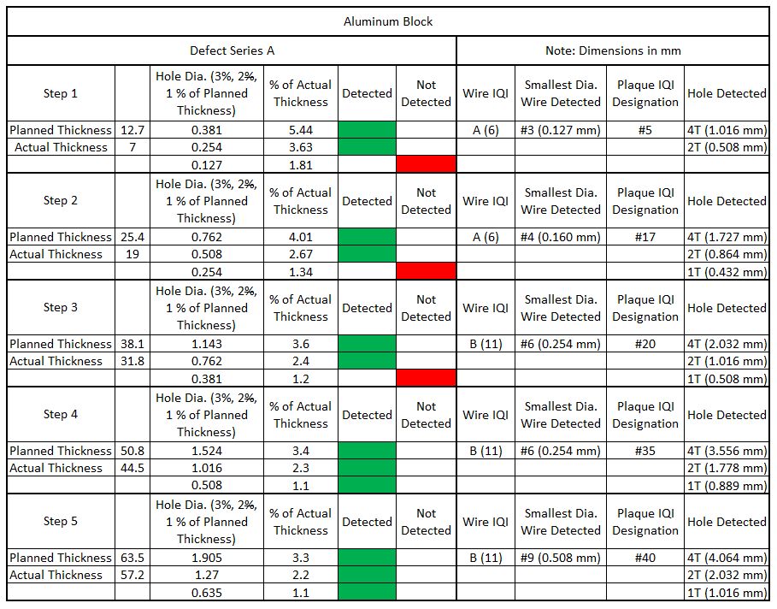

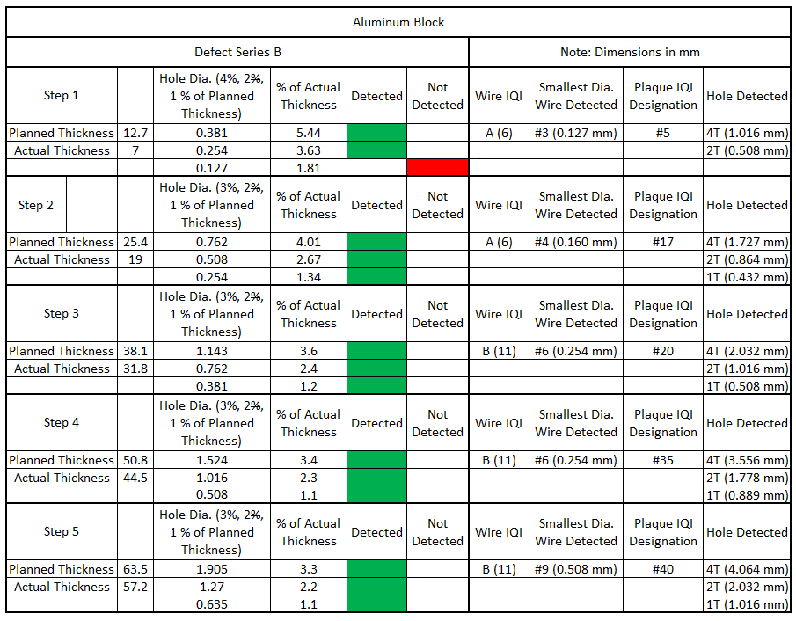

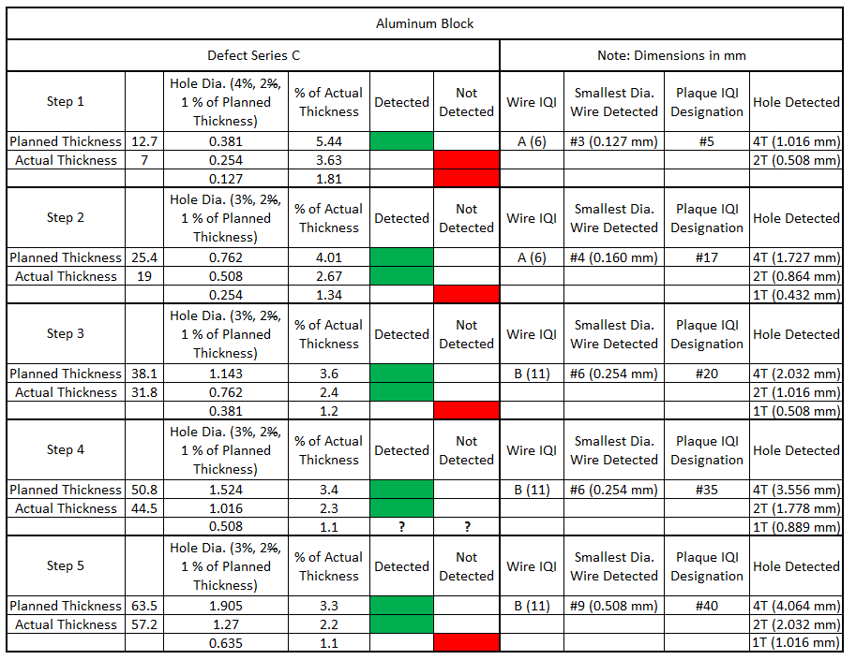

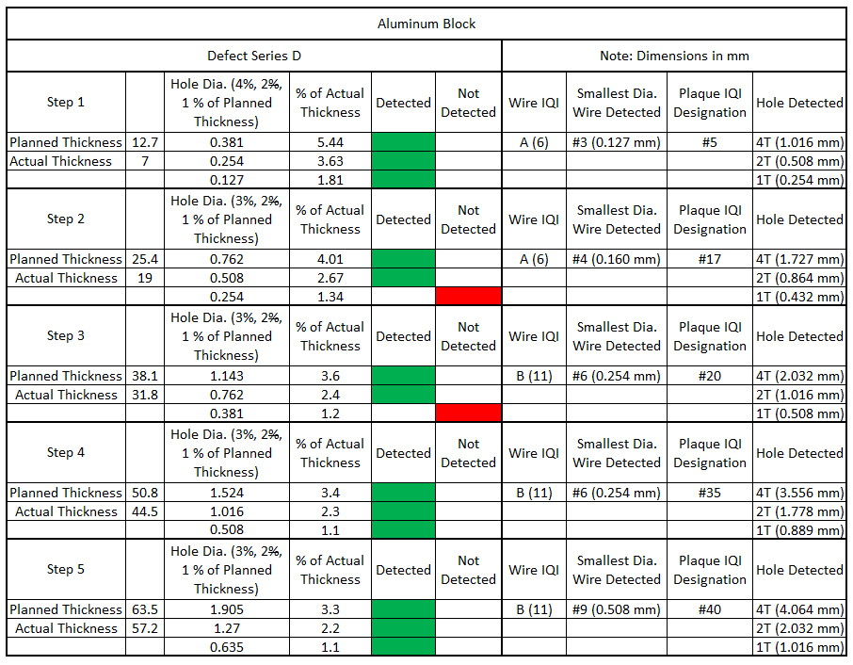

**Chart 5 Ultrasonic results**

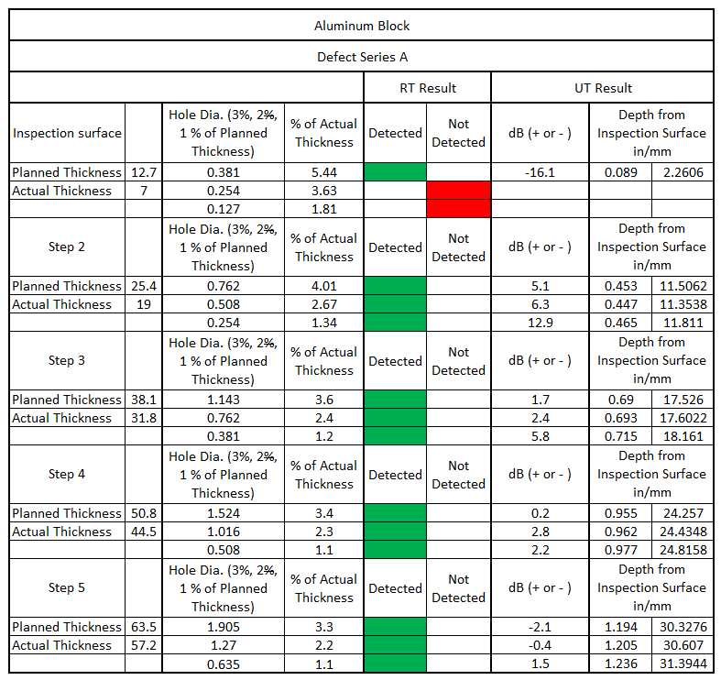

Note: A negative dB rating indicates the amount of gain

reduction to reduce echo amplitude to the reference echo height.

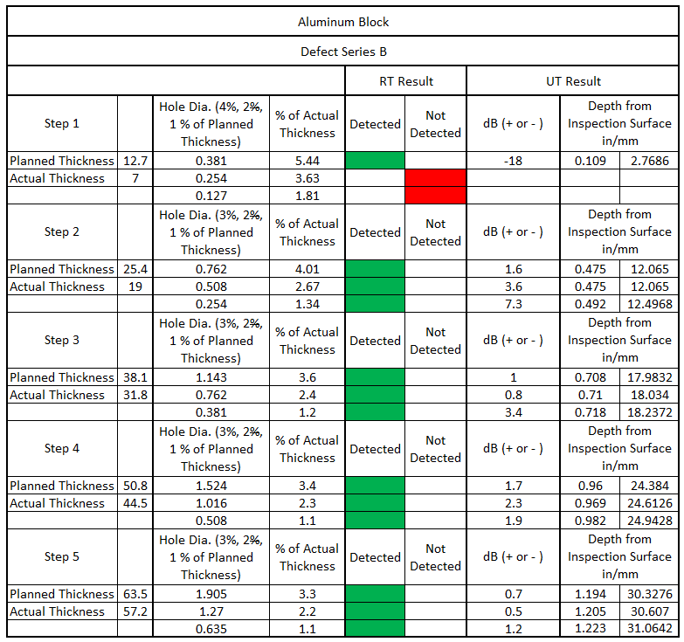

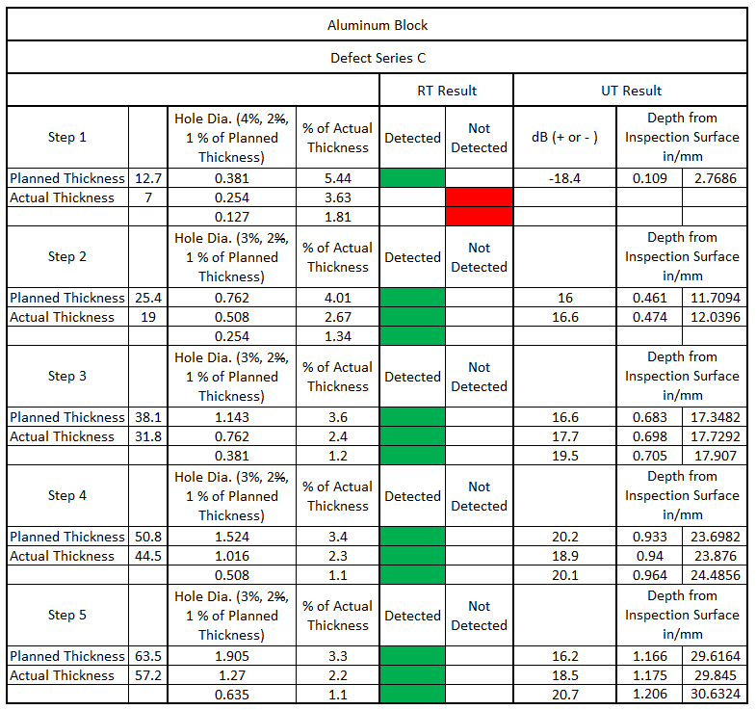

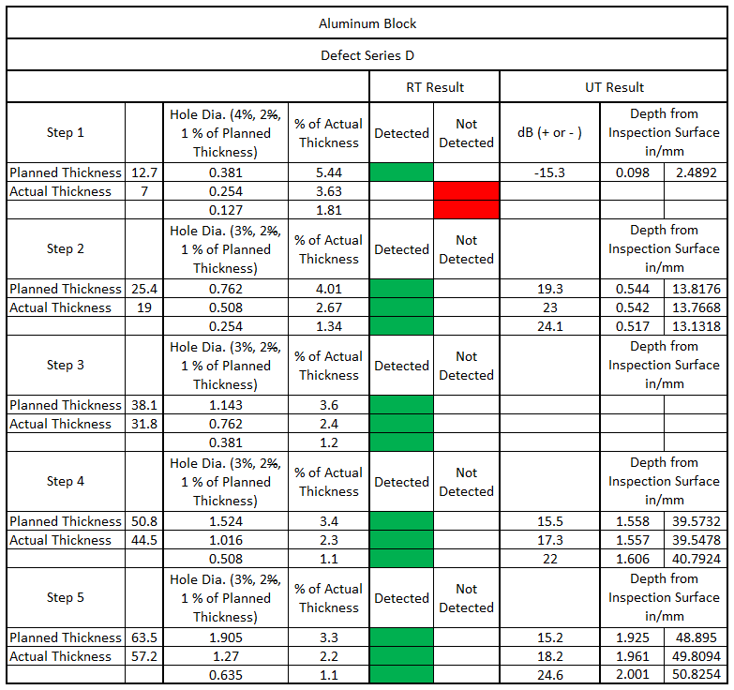

Following the work completed by CINDE, Pratt &Whitney Canada performed X-ray computed tomography on the specimen. Results were definitely favourable with the 4 series of implanted discontinuities being detected. With the capability to view the specimen in multiple “cuts” or sections, it was obvious that the conventional IQI’s used may not be appropriate with the capability of the advanced radiographic inspection.

Since that time several new IQI’s have been proposed and are in the development stage before they are produced by AMIC. Possible designs would incorporate features which are integral to existing wire-type or plaque-type IQI’s, but would add a 3rd dimensional aspect as well. Interior features are also proposed to be incorporated into the IQI.

Design of any new IQI must consider:

* IQI must be kept near the surface of the part. Current IQI’s are placed in contact with the surface of the part and do not incur additional geometric enlargement or the possibility of any penumbral shadow.
* Can the IQI’s be successfully 3D printed with the required dimensional accuracy, especially if interior features are present.
* If interior features are present will it be possible to ensure complete removal of the unfused powders.
* What is the limitation of IQI thickness that can 3D printed with the features required, as standard IQI’s are based on a percentage thickness as part of their design.
* Are there any restrictions in size or detail within the various materials/groups which can be printed.

Ongoing work in partnership with CINDE, Pratt &Whitney Canada and Mohawk’s AMIC will seek to resolve these challenges.

Acknowledgements

Thanks to S. Bond and C. Pancescu, CINDE for the PT and UT efforts.

## References

1. **A. Vevers, A. Kromanis, E. Gerins, & J. Ozolins**, *Additive Manufacturing and Casting Technology Comparison: Mechanical Properties, Productivity and Cost Benchmark,* Latvian Journal of Physics and Technical Sciences, Vol. 55, Issue 2, 2018.
2. **F.Trevisan, F. Calignano, M. Lorusso, J. Pakkanen, A. Aversa, E.P. Ambrosio , M. Lombardi, P. Fino, D. Manfredi**, *On the Selective Laser Melting (SLM) of the AlSi10Mg Alloy: Process, Microstructure, and Mechanical Properties*, Materials (Basel), Vol 10, Issue 1, Jan. 2017.
3. **T. G. Spears & S. A. Gold,** *In-process sensing in selective laser melting (SLM) additive manufacturing,* Integrating Materials and Manufacturing Innovation, Vol 5, Issue 1, Article 2, December 2016.
4. **S. Shrestha & K. Chou** *Porosity Analysis in Metal Additive Manufacturing by Micro-CT*, Proceedings of Bruker Micro-CT User Meeting, Belgium, April 2018, Page 89.
5. **J. M. Waller** *Non-destructive Testing of Additive Manufactured Metal Parts Used in Aerospace Applications*, NASA-JSC WSTF, ASTM International Webinar, Session I and II Feb 2018.
6. **Z. Prevorovsky, J. Krofta, & J. Kober** *NDT in Additive Manufacturing of metals,* 9th International Workshop NDT in Progress, Oct 9-11, 2017, Prague, Czech Republic
7. EOS material data sheets <https://www.eos.info/material-m>
8. EOS material data sheets <https://www.eos.info/material-p>