The effect of higher harmonic components on MPI process

Pavel STANĚK¹, Zbyněk ŠKVOR¹

¹ Faculty of Electrical Engineering, Czech Technical University in Prague, Prague, Czech Republic
Phone: +420 22435 2271, +420 22435 2278, e-mail: stanepa2@fel.cvut.cz, skvor@fel.cvut.cz

Abstract
Magnetic Particle Inspection (MPI) relies on magnetic forces driving small ferromagnetic particles. Such forces are caused by inhomogeneities (cracks) in ferromagnetic bodies perpendicular to magnetic field intensity. In order to detect defects in all possible directions it is essential to create rotating magnetic field tangential to the surface of the material under test. Such a field is required when the direction of discontinuities is unknown. The field polarization is usually tested by the Quantitative Quality Indicators (QQI). These indicators verify in which directions the field strength is adequate. If the field is indicated by QQI as a sufficient in all directions it is often called circular polarization, despite the fact it may not be really circular polarized. Measurements have shown that the polarization is elliptical at its best [1].

The rotating magnetic field ideally consists of two perpendicular harmonic components of equal frequency and a ninety degrees mutual phase shift. In a presence of a nonlinear material (which is mostly the case) higher harmonics are generated. Moreover, heavy use of switching sources has changed power AC current waveform that it is no longer sinusoidal.

Higher harmonic components are likely to change the magnetic field polarization nature. This paper investigates nonlinear effect and its impact on a polarization of magnetic field and MPI detection ability. It has been found that higher harmonic components may cause blind angles, eg. directions in which cracks are not likely to be detected. Examining the impulse of magnetic force affecting a particle, the total effect of higher harmonic components in MPI process is evaluated.

Keywords: Magnetic particle inspection, polarization, nonlinearity, magnetic force

1. Introduction

MPI is based on a difference in permeability of the tested specimen and the potential flaw. The specimen is magnetized by the field of adequate magnitude and convenient direction. If the surface-breaking flaw is present, it distorts the magnetic field, and creates so called magnetic leakage flux. The magnetic field becomes inhomogeneous around the flaw and attracts the detection particles towards the flaw.

The best detection is achieved when the magnetic field is perpendicular to the flaw, but it is usually considered that the angle between the flux and the flaw should not fall under forty-five degrees to create sufficient indication. In order to detect the defects in all possible direction a rotating magnetic field is required. The rotating field can be created as a combination of two perpendicular components.

Before the indication particles are applied, the generated magnetic field should be verified whether it is sufficient in all directions. There are limited possibilities of doing that. This paper suggests a new verification method based on the vector magnetic measurement presented in [1].

2. Magnetic field verification

It is important to know whether the field intensity is adequate in all directions at any given point within the tested area. There are a few methods how to inspect generated magnetic field for MPI procedure. One of them is to use the artificial defects such as Quantitative Quality Indicators (QQI). QQIs are artificially-flawed, steel specimens, which show the directions in which the field is adequate for successful detection. Disadvantage of these indicators is that they must be first fixed on the tested surface, so that the air gap between gauge and surface of tested material is minimal, and then the standard steps of MPI procedure must be performed.

Another option is to use specimens with known real defects for verification of the field, but they can hardly verify the field in all directions. Common praxis is also to measure the tangential component of the field by a gaussmeter. The most of these gaussmeters measure only RMS value in one direction.

None of the above mentioned techniques can provide full information about the magnetic field. For this propose the experimental vector gaussmeter for the field measurements was developed. [1] The experimental measurements show that even if the field is indicated by a QQI as sufficient in all directions it may not be really circular polarized. The polarisation can be much more complex.

3. Polarization

The parametric representation of so far called rotating field in $xy$ plane is

 | $$x=a_{1}\cos\left(ωt\right)$$ | (1)
 | $$y=b_{1} sin\left(ωt\right),$$

where $ω$ is angular velocity and $t$ is time. These two equations describe general elliptical polarization in a plane, in a special case $a_{1}=b_{1}$ the polarisation is circular. If we assume that both components are general continuous functions, we can represent them by the Fourier series in the trigonometric form
 | $$x=\frac{a_{0}}{2}+\sum_{n=1}^{∞}{(a_{n}\cos\left(nωt\right)+b_{n}sin⁡(nωt))}$$ | (2)
 | $$y=\frac{c_{0}}{2}+\sum_{n=1}^{∞}{(c_{n}\cos\left(nωt\right)+d_{n}sin⁡(nωt))},$$

where $a_{n}$,$b_{n}$,$c_{n}$ and $d_{n}$ are Fourier coefficients of harmonic component.

4. Leakage field of elliptical defect

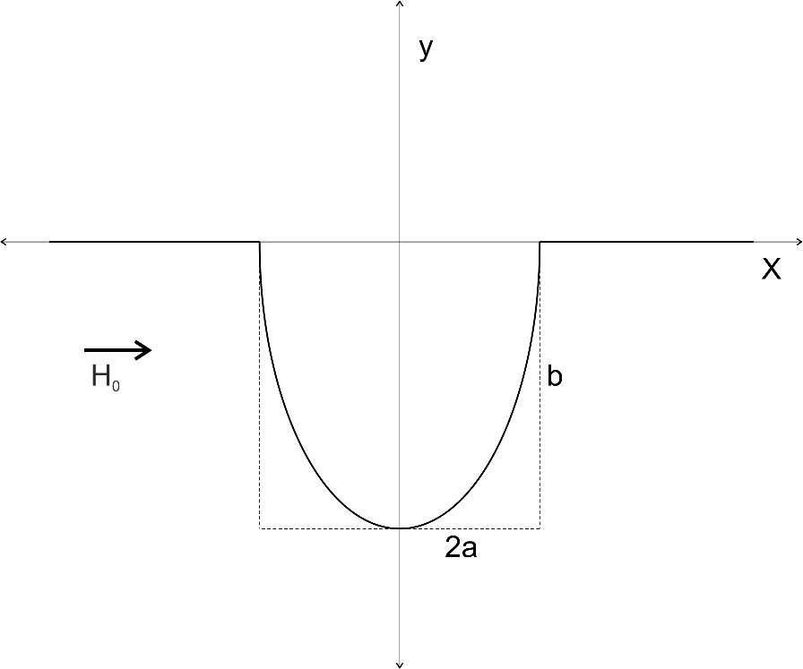
The paper [2] by Edwards and Palmers investigates the leakage field above the surface breaking of the elliptical shape. The expression for the leakage field components and the force on a spherical particle in the leakage field is presented in a closed analytical form.
Figure 1 – Semi-elliptical surface breaking
The calculation assumed an infinitely long boundary between air and linear material with semi-elliptical breaking at the coordinate origin with a dimensions shown in the Figure 1. The magnetic field components $H_{x}$ and $H_{y}$ are given by equations
 | $$H_{x}=H_{0}\frac{n\left(μ-1\right)}{2\tan^{-1}\left(n\left(n+μ\right)\right)}\left(\tan^{-1}\left(\frac{b\left(x+a\right)}{{\left(x+a\right)}^{2}+y\left(y+b\right)}\right)-\tan^{-1}\left(\frac{b(x-a)}{{\left(x+a\right)}^{2}+y\left(y+b\right)}\right)\right)$$ | (3)

 | $$H_{y}=H_{0}\frac{n\left(μ-1\right)}{4\tan^{-1}\left(n\left(n+μ\right)\right)}ln\left(\frac{{((x+a)}^{2}+{(y+b)}^{2})({\left(x-a\right)}^{2}+y^{2})}{{((x+a)}^{2}+y^{2})({\left(x-a\right)}^{2}+{(y+b)}^{2})}\right).$$ | (4)

The force components $F_{x}$ (tangential to the surface) on a spherical particle of a radius $r$ is
 | $$F_{x}=-\frac{8}{3}μ_{0}πr^{3}\left(\left(H_{0}+H_{x}\right)\frac{∂H_{x}}{∂x}+H_{y}\frac{∂H_{y}}{∂x}\right).$$ | (5)
This component is important for detection process, because it is responsible for driving the particles towards the defect. Complete calculation can be seen in [2].

5. The force impulse

As previously mentioned there are limited possibilities how to verify whether the generated magnetic field is adequate for successful MPI process over the whole area under test. In part two the possibilities of field verification were summarized. In this part the theoretical postprocessing method of measured field is suggested. It requires vector measurement of magnetic field components in a plane close to the surface. The force impulse (affecting a particle) is calculated from the measured data.

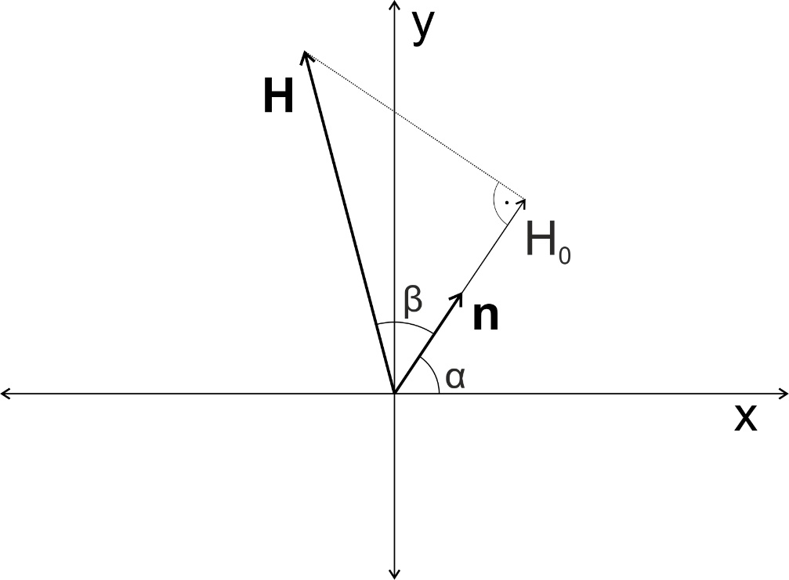
Let assume the magnetic field vector $H$ varying in the time in $xy$ plane with the polarization described by a Fourier series $H=(\frac{a_{0}}{2}+\sum_{n=1}^{∞}{(a_{n}\cos\left(nωt\right)+b_{n}sin⁡(nωt))}, \frac{c_{0}}{2}+\sum_{n=1}^{∞}{(c_{n}\cos\left(nωt\right)+d_{n}sin⁡(nωt))})$. The vector $n=(\cos\left(α\right),sin(α))$ is the unity vector perpendicular to the surface rupture. $H_{0}$ is the projection of $H$ in the direction of $n$. The situation can be seen in the Figure 2.
Figure 2 – Field vectors

Projection $H_{0}$ can be calculated as

 | $$H_{0}=\left|H\right|\cos\left(β\right)=\left|H\right|\frac{H∙n}{\left|H\right|\left|n\right|}=H∙n=$$
 | $$=cos\left(α\right)\frac{a_{0}}{2}+\cos\left(α\right)\sum_{n=1}^{∞}{{(a}_{n}\cos\left(nωt\right)}+b_{0}\sin\left(nωt\right))+sin\left(α\right)\frac{c_{0}}{2}+sin\left(α\right)\sum_{n=1}^{∞}{{(c}_{n}}\cos\left(nωt\right)+d_{n}sin\left(nωt\right))$$ | (6)

where $β$ is angle between $n$ and $H$.

The equation 5 can be rewritten in the following form
 | $$F_{x}=-\frac{8}{3}μ_{0}πr^{3}\left(H_{0}\frac{∂H_{x}}{∂x}+H_{x}\frac{∂H_{x}}{∂x}+H_{y}\frac{∂H_{y}}{∂x}\right)=$$ | (7)
 | $$=-\frac{8}{3}μ_{0}πr^{3}H_{0}^{2}\left(\frac{∂{\overline{H}}_{x}}{∂x}+{\overline{H}}_{x}\frac{∂{\overline{H}}_{x}}{∂x}+{\overline{H}}_{y}\frac{∂{\overline{H}}_{y}}{∂x}\right)=kH_{0}^{2},$$
where ${\overline{H}}_{x}=H_{x}/H_{0}$ and ${\overline{H}}_{y}=H_{y}/H_{0}$. It can be clearly seen that $F_{x}≈H_{0}^{2}$.

The detection ability of MPI depends on many factors but the most critical are force and the duration of the presence of the magnetic field. This can be quantified by the force impulse. Since we consider the periodic repetition of the field components the relevant value is integral over one base period. For longer time duration it becomes a multiple of this value. The base period is $T=\frac{1}{f}=\frac{2π}{ω}$. The force impulse equals
 | $$I=\int_{0}^{T}{kH_{0}^{2}dt}=k\int_{0}^{T}{{\left(cos\left(α\right)\frac{a_{0}}{2}+\cos\left(α\right)\sum_{n=1}^{∞}{{(a}_{n}\cos\left(nωt\right)}+b_{0}\sin\left(nωt\right))+sin\left(α\right)\frac{c_{0}}{2}+sin\left(α\right)\sum_{n=1}^{∞}{{(c}_{n}}\cos\left(nωt\right)+d_{n}sin\left(nωt\right))\right)}^{2}dt.}$$ | (8)
Using the rule for square of sum and the fact $\int_{0}^{T}{\sin\left(nωt\right)\cos\left(mωt\right)dt=0}$, the equation 8 can be simplified
 | $$I=\frac{k}{2f}\left[\cos^{2}\left(α\right)\left(\sum_{n=1}^{N}{a_{n}^{2}}+\sum_{n=1}^{N}{b_{n}^{2}}-\sum_{n=1}^{N}{c_{n}^{2}}-\sum_{n=1}^{N}{d_{n}^{2}}\right)+\sin\left(2α\right)\left(\sum_{n=1}^{N}{a_{n}c_{n}}-\sum_{n=1}^{N}{b_{n}dc_{n}}\right)+\sum_{n=1}^{N}{c_{n}^{2}}+\sum_{n=1}^{N}{d_{n}^{2}}{+2\left(\cos\left(α\right)\frac{a_{0}}{2}+\sin\left(α\right)\frac{c_{0}}{2}\right)}^{2}\right]= \\ =\frac{k}{2f}\left[\cos^{2}\left(α\right)\left(\sum_{n=1}^{N}{{(a}_{n}^{2}+b_{n}^{2})}-\sum_{n=1}^{N}{{(c}_{n}^{2}+d_{n}^{2}})+\frac{a_{0}^{2}}{2}-\frac{c_{0}^{2}}{2}+\right)+\sin\left(2α\right)\left(\sum_{n=1}^{N}{a_{n}c_{n}}-\sum_{n=1}^{N}{b_{n}dc_{n}}+\frac{a_{0}c_{0}}{4}\right)+\sum_{n=1}^{N}{c_{n}^{2}}+\sum_{n=1}^{N}{d_{n}^{2}}+\frac{c_{0}^{2}}{2}\right].$$ | (9)

6. Discussion

The force impulse consist of three terms. The first term in equation 9, which contains $\cos^{2}\left(α\right)$, shows that the more different the corresponding coefficients are the higher degradation of the detection ability would occur. The second term varies with a double frequency and the
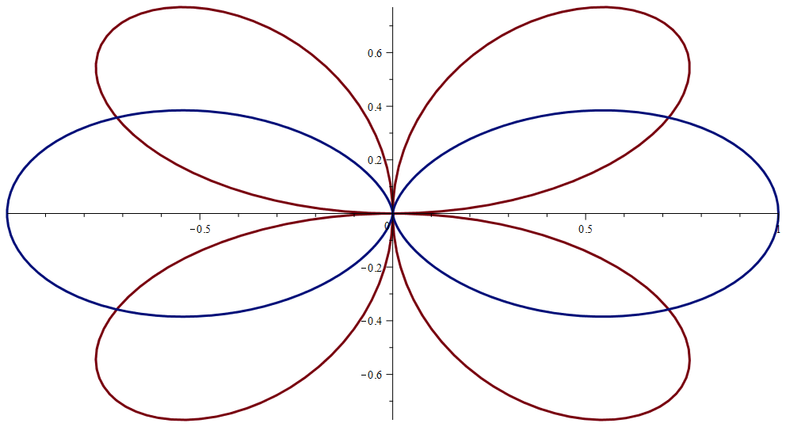
Figure 3 – Polar plot of cos²(α) (blue) and sin(2α) (red)
magnitude is given by a product of the mixed coefficients. The polar plot of $\cos^{2}\left(α\right)$ and $sin\left(2α\right)$ are shown in Figure 3. These two terms may result in blind angles. The last term $\sum_{n=1}^{N}{c_{n}^{2}}+\sum_{n=1}^{N}{d_{n}^{2}}+\frac{c_{0}^{2}}{2}$ is not dependent on angle $α$, which means that it increases the detection ability in all directions.

7. Conclusion

The paper summarizes the possibilities of the magnetic field verification for MPI process. Since the force on the detection particle and its duration in is time are the most critical quantities the new method based on the force impulse calculation is suggested. This method requires data from the vector measurement of magnetic field.

References

1. P Staněk, Z Škvor, M Roxer, 'Experimental Gaussmeter for Circular Magnetization', presented at NDT in progress 2017, (pp. 104-107), Prague, 2017.

2. C Edwards and S B Palmer, 'The magnetic leakage field of surface-breaking cracks', J. Phys. D: Appl. Phys. 19 657, 1986.

